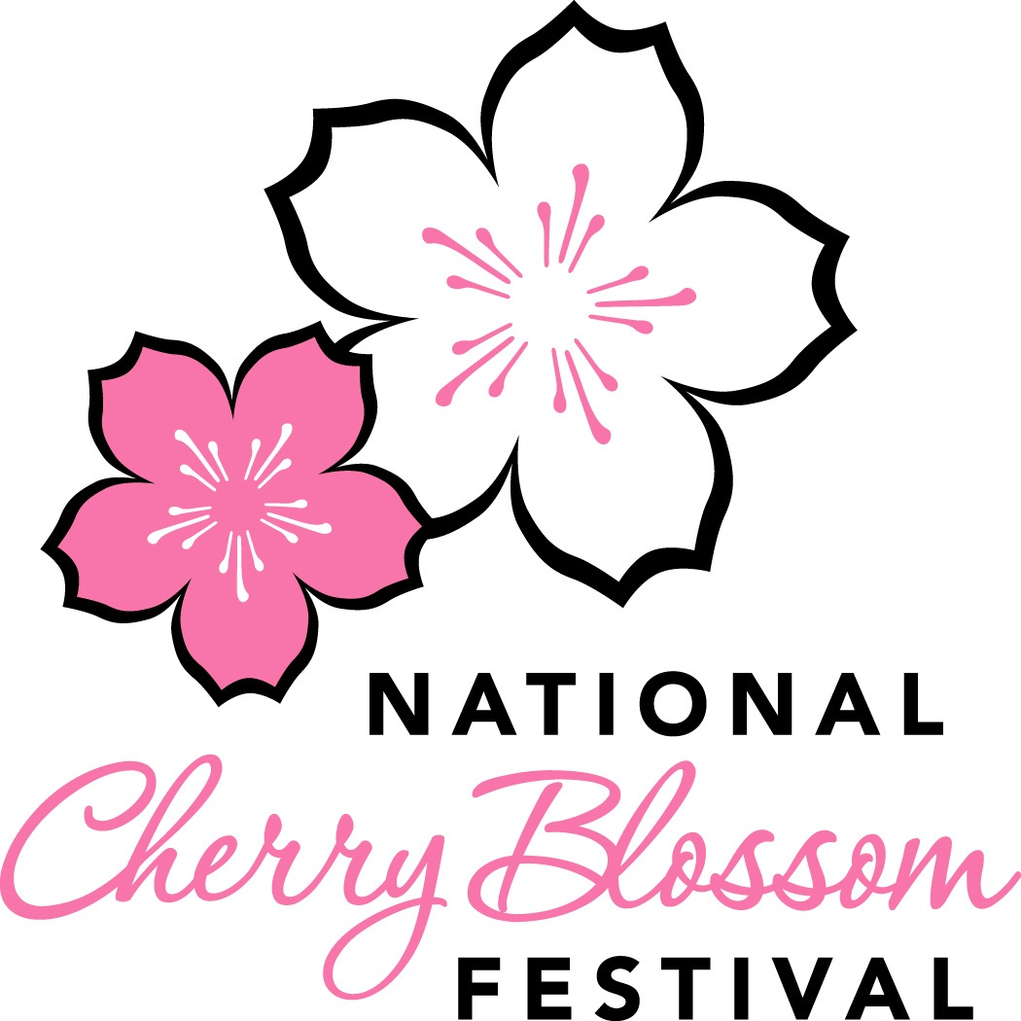
2018 National Cherry Blossom Festival Parade®
Adult Participant Release Form

(Please Print in Black or Blue Ink Only)

I, the above individual, want to participate in the National Cherry Blossom Festival Parade scheduled to take place on Saturday, April 14, 2018 along Constitution Avenue between 7th and 17th Streets, NW, Washington, DC (“Event”). I will:

1. Certify that I am at least 18 years old, physically fit and able to participate in the Event.

2. Participate in the Event and notify my Event supervisor if I am not able to perform a requested task.

3. Acknowledge that I will not be compensated for my participation in the Event.

4. Assume all risks of personal injury, property loss or death that may occur related to my participating in the Event. Along with my heirs, executors and administrators, I waive all current and future legal claims against the National Cherry Blossom Festival, Inc., the District of Columbia, the National Park Service, EventsDC, JM Best Entertainment Inc., Under the Sun Productions Inc., WJLA-TV and each of their respective sponsors, officers, directors, employees, agents, representatives, successors, and assigns (collectively, “Presenters”).

5. Acknowledge that I am not covered by any Presenter’s insurance.

6. Authorize any necessary medical treatment to me at the Event, at my cost.

7. Indemnify and defend, together with my heirs, executors and administrators, the Presenters from all liabilities, claims, actions, damages, costs or expenses, including claims based on a Presenter's negligence, arising out of or connected with third party claims related to my participation in the Event.

8. Not take any action that would negatively impact the reputation of NCBF or the Festival. I will leave the Event if NCBF requires.

9. Allow NCBF and NCBF’s agents, without reservation, limitation or additional compensation, to record, in any media, and use, broadcast or produce derivative works from, in any media and for all time, my name, face, likeness, voice and appearance.

Date: _______________________ Signature: _________________________________________

If you are participating with an organization or group, please list the name of that organization or group:

George Washington Chapter of the Model A Ford Club ______________________________________________________________

